Artificial Intelligence based Supply Chain Demand forecasting for the Shipping Industry

### 

### 

### 

### 

### 

### 

RGU Id: 1812897

IIT Id: 2018099

Table of Contents

**Introduction** **3**

**Literature Review** **4**

**Motivation** **5**

Aim 6

Objectives 7

**Research Methodology** **7**

**Prototype Specification** **8**

**Data Management Plan** **10**

**Time Scale** **11**

**Conclusion** **12**

**References** **13**

### 

### 

### 

### 

### Introduction

Supply chain industry is the third highest revenue driver out of Artificial Intelligence (AI) as of today. The trend is upward and possible innovations using AI is expanding at a rapid rate. Goods and services flow from suppliers to end customers through a chain of middlemen. In simple terms, this entire chain and everything that involves in between can be taken as belonging to what business and finance world calls as “supply-chain”.

A supply chain may involve a multitude of players among which Shipping companies are vital. Shipping in general sense refers to transporting of items of different scale. In supply chain context, shipping refers to companies who handle cargo shipments from location to locations.

A shipping company relies on its partners for revenue. The revenue largely rely on fluctuations of demand and supply of cargo in areas they operate. The impact of demand and supply for commodities can have heavy impacts on vessel utilization for shipping companies. This in turn affects the revenue and wastage. For larger scale companies the fluctuations are less impactful because of market balance forces. For starters and small shipping firms fluctuations per commodity is more important because they in turn can have a heavy impact on cargo supplies. Be it an increased demand or a fall down. This leads to a requirement of better planning systems to plan future operations. To list a few benefits out of such predictive forecasting could be,

* Repositioning vessels.
* Streamlining marketing processes by identifying commodities.
* Reducing waste of vessel space.
* Improving service delivery.
* etc..

Solving demand prediction problems in SCM using AI methodologies has its own set of problems among which a lot of researchers have done research to solve one or another fully or partially. One such model that has been tried is a simulation model where researchers break the supply chain for a good into four and simulate each of their behaviour. Different machine learning models have shown different levels of accuracy when it comes to this way of prediction (Vahidov ,2007).

**Problem formulation / Research question**

Let’s assume we have a set of documents called D.

Let’s say, set of all polarization classes is $Pα = \{negative, positive, neutral\}$

There exist $f(α) : D -> Pα$. $f(α)$ is the polarization function of $D$.

The hypothesis we are assuming is, there exist $G(β) : P(α) -> D$. Our entire research focuses on figuring out this $G($ $β)$ given $D$.

### Literature Review

Literature review of this research has to be done using highly subjective resources. This is because most of the useful research done in the area has been done after on specific commodities. Limitations of such commodities have a higher influence on the outcome of such research. Bias is considered when adapting phenomenon presented by such research.

Following is the taxonomy of the literature review in summary.

Modern Methodologies & Concepts

* Methodologies.
  + Structural risk minimization models
    - Support Vector Machine
  + Empirical risk minimization models
    - Neural Networks
    - Recurrent Neural Networks
    - Logistic regression
    - Simulation
* Traditional concepts
  + - Naı¨ve forecasting
    - Moving average
    - Linear regression.
    - Collaborative forecasting and replenishment (CFAR)

### Motivation

In the usual practice of data science of supply chain analysis usually results in some charts and tables providing insights for stakeholders on what the particular target audience thinks about a topic/product/etc. This can be improved into a completely developed science/engineering area of study. The term engineering is preferred because this refers to the practice of reuse and applying theories already developed.

A practice of engineering in the field of supply chain analysis benefits stakeholders in many ways,

1. It helps stakeholders identify strategies that work best. This one step ahead from what supply analysis usually gives.
2. It helps stakeholders identify patterns in supply chain change combined with the context.
3. It helps stakeholders directly identify context changes need to be done to achieve a target demand distribution.
4. Such insights can be used as inputs to other researches, such as stock market prediction models.

#### 

#### 

#### Aim

This project aims to explore models and identify the right model to predict demand of rubber in a selected region.

#### Objectives

* To identify real/hypothetic datasets relating to supply chain distributions and contexts.
* To collect/generate real sample datasets relating to supply chain distributions and contexts.
* To develop (a) deep learning model(s) consuming the collected dataset and a simple application infrastructure consuming the deep learning model(s).
* To develop a demonstration system consuming the models developed.
* To gather and analyze user feedback in order to estimate the effectiveness of the developed models in supply chain analysis.

### 

### Research Methodology

It is debatable whether research on opinions can be considered quantitative or qualitative. The problem we are solving here can be seen as an attempt to determine the right quantitative dataset and models. And our output is a quantified result. Hence, this is a quantitative research.

The planned methodology consists of the following steps. A step can be revisited more than one time, but the research flows iteratively.

* Selecting and collecting datasets.
* Identifying a candidate list of content-based models for the SA.
* Identify a candidate list of context-based models for the SA.
* Evaluating combinations of each of those models and selecting the best suited.
* Identifying the model operating on the inverse model of the selected model.
* Evaluating the inverse function.

Finally, the demonstration system is developed using basic web technologies. This system will then be produced to a sample set of users for feedback.

Given below is a sample extract of the questionnaire that will be used to evaluate the outcome of the research.

Following is a sample open-ended questionnaire.

1. How well the system predicts demand hange?
2. How useful the insights the system provides in opinion shift based on context.?
3. Give us a few use cases for this system?
4. What can be done to improve the system?

…………………………

### Time Scale

The research spans across a 10-month period. Following is the Gantt chart based on current estimates.

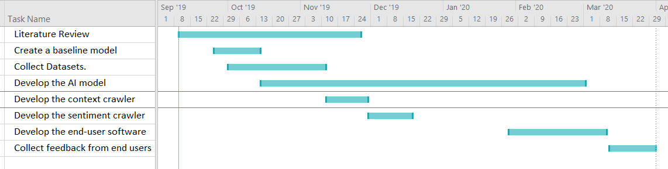

### 

### Proposed solution

Following is a sample set of target user interface wireframes to be developed to consume the models we develop.

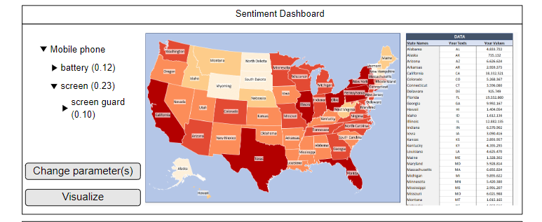

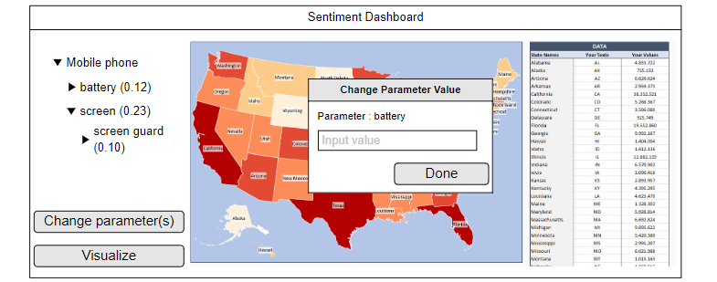

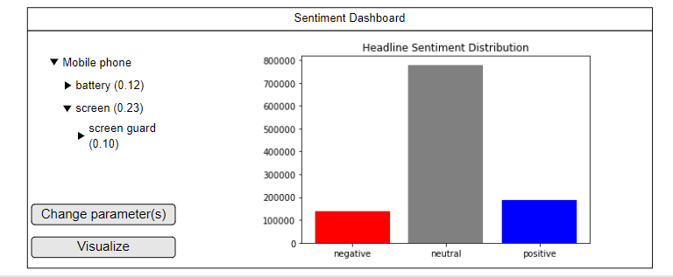

The target user of the above system is a c-level executive. The system helps analysts determine what parameters in the public discourse need to be addressed in order to achieve a change in the demand map. This insight can be useful for a various range of users..

### Data Management Plan

**Datasets**

Datasets for this project are mainly taken from two sources.

1. Twitter
2. Kaggle

**Privacy**

As the data to be collected might involve privacy issues of individuals, due care will be taken to comply with existing laws on the global level and regional levels. For the global level, the project follows “Fair information Practice” principles developed in the USA in the 1970s as that is much straightforward and accepted by many. Furthermore, laws affecting regions to be followed concerning users from respective regions, a few such regulations to mention are,

For EU:- General Data Protection Regulation

For the UK:- Data Protection Act 2018

For North America:- Personal Information Protection and Electronic Documents Act (PIPEDA)

For the South Asian region - PERSONAL DATA PROTECTION BILL, 2018 (India)

For Sri Lanka:- Computer Crimes Act No. 24 of 2007

Furthermore, it’s worth mentioning that this project doesn’t collect any personally identifiable information under any circumstances.

**Technologies**

Python as a language and tools built using python will be used for data engineering and model building tasks. Following is a set of tools intended to be used in this project.

* Protege
* Twinkle
* Jupyter Notebook
* Spyder 3
* Python 3.7
* Microsoft Excel

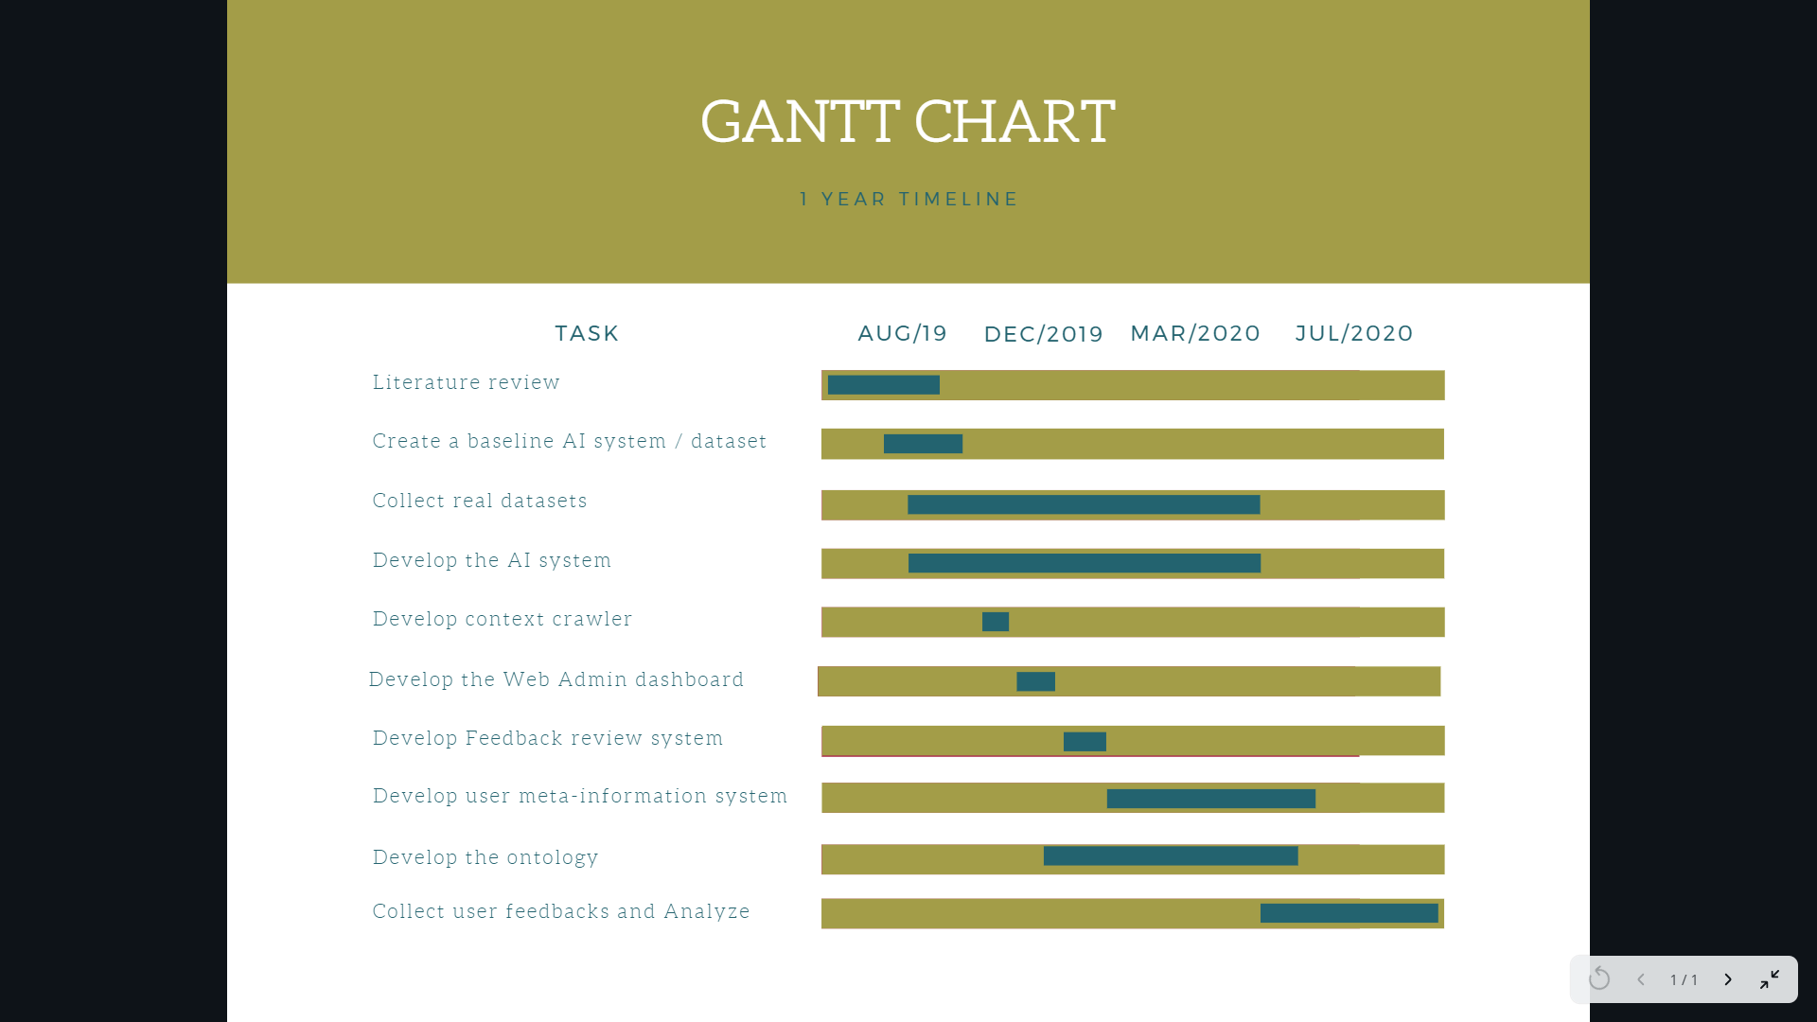

### Conclusion

**Contributions**

A few contributions of this research can be listed as below,

* Best suited model for demand prediction.
* Evaluation of models against suitability for demand prediction..
* A demonstration system utilizing the models and user feedback on the same.

A part of this output comes under software engineering, but the user experience part has to be researched.

Additionally, we will be producing,

1. Meta datasets for domains.
2. Meta datasets for a sample set of individual actors (anonymously provided)

**Future works**

Based on the outcome of this project there are a numerous amount of research can be done. A few obvious such examples are,

* Generating content using generative models using context change parameters.
* Domain-specific public opinion changing strategies.
* Developing marketing strategies using the insights provided.

### References

References are given in each page where citations are done.